Big data Lab – 01

commands
>mongo

> use praneeth
switched to db praneeth

show databases
>show dbs

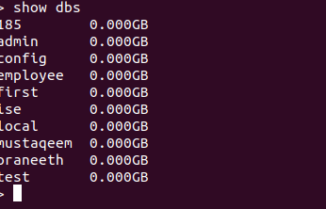

Insert One
> db.praneeth.insertOne(
... {
... "name":"sai",
... "dept":"ise"
... }
... )
{
"acknowledged" : true,
"insertedId" : ObjectId("624bb7e86c34e36167caa1e0")
}

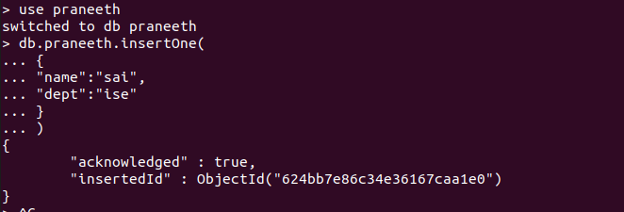

Counting
> db.madhu.count()
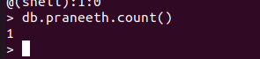

Insert Many
db.praneeth.insertMany([
... { "name":"raj","dept":"ise"}
... ,{"name":"sohan","dept":"cse"},
... {"name":"dnd","dept":"mech"},
... ])

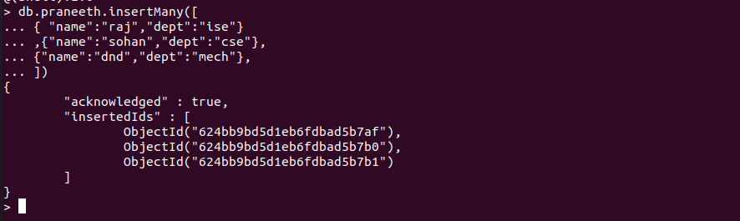

Reading
db.praneeth.find()
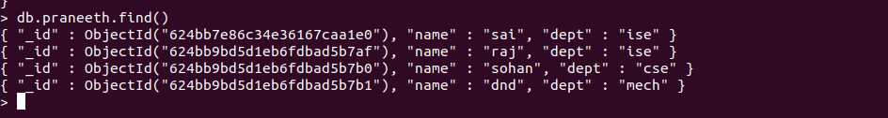

> db.praneeth.find().pretty()

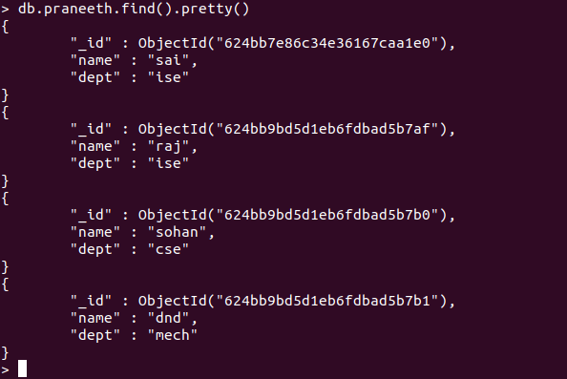

Update One
db.praneeth.updateOne({“name”:”raj”},
... ... {
... ... $set : {"dept" : "ec" }
... ... }
... ... )

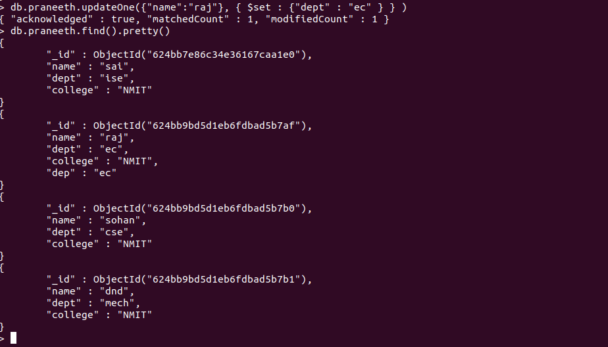
Update Many
db.praneeth.updateMany({},
... ... {
... ... $set : {"dept" : "EC" }
... ... }
... ... )

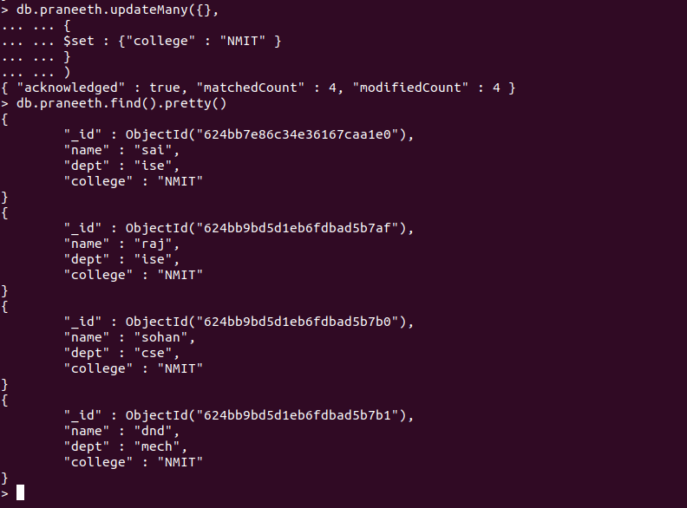
Delete One
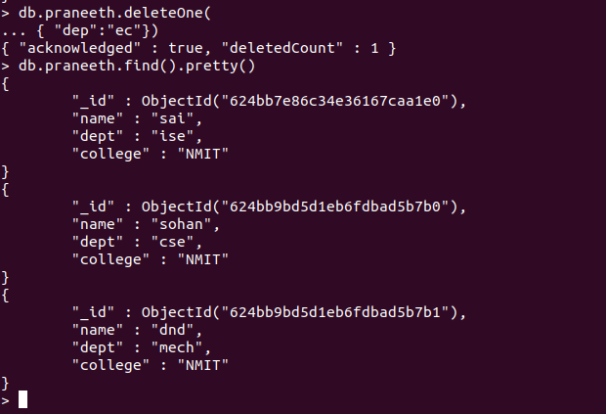
db.praneeth.deleteOne(
... { "dep":"ec"})
Delete Many
> db.praneeth.deleteMany(
... {"dept":"ec"})
{ "acknowledged" : true, "deletedCount" : 0 }
> db.praneeth.deleteMany( {"dept":"mech"})
{ "acknowledged" : true, "deletedCount" : 1 }
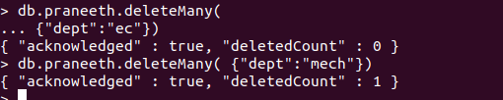

Replace One
> db.praneeth.replaceOne( {"name":"dnd"},{"name":"sai", "dept":"ec"})
{ "acknowledged" : true, "matchedCount" : 0, "modifiedCount" : 0 }
> db.praneeth.replaceOne( {"name":"sohan"},{"name":"sai", "dept":"ec"})
{ "acknowledged" : true, "matchedCount" : 1, "modifiedCount" : 1 }

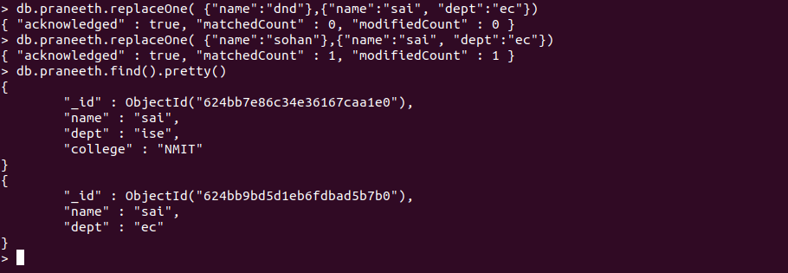

Unset
> db.praneeth.updateMany({}, { $unset: { "dept": "ec" } })
{ "acknowledged" : true, "matchedCount" : 2, "modifiedCount" : 2 }
> db.praneeth.find()

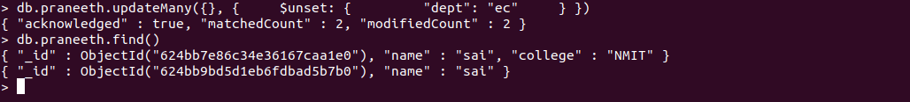

Set
> db.praneeth.updateMany({}, { $set: { "dept": "ec" } })
{ "acknowledged" : true, "matchedCount" : 2, "modifiedCount" : 2 }
> db.praneeth.find()
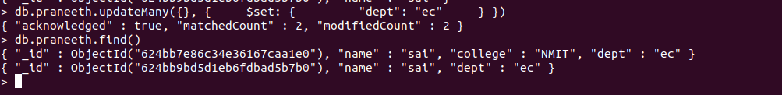
Or
db.praneeth.find({$or: [{dept: "ec"},{dept:"mech"}]}).pretty()
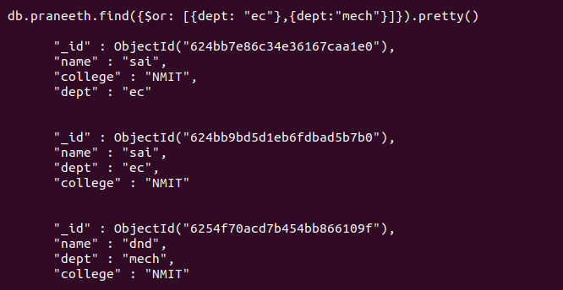

And

db.praneeth.find({$and: [{dept: "ec"},{college: "NMIT"}]}).pretty()

